**English for web developers**

**1-CE-X75-A**

By Dorina-Milena Curici

Course given at EFP

2021-2022

# Class I

## Talking about yourself + questions

*Questions*:

1. What's your name?

2. Where do you come from? / Where are you from?

3. How old are you?

4. What's your job? / What do you do?

5. Do you have and email address? What is your email address? Could you give it to me?

6. Do you have a phone? Could I have your phone number?

7. Do you have any siblings?

8. What are your hobbies/interests? / What do you like to do?

9.When is your birthday?

10. Do you have any children?

11. What is your civil status?

12. What is your favourite food?

*Answers*:

1. My name is Dorina.

2. I am / I come from Romania.

3. I am 35 (years old).

4. I work as an English trainer for EFP.

5. My email address is dorina_milena@yahoo.co.uk.

6. My telephone number is 0491907336.

7. I don't have any siblings / I am an only child. (brothers, sisters)

8. I like/I am interested in sports, reading and travelling.

9. My birthday is on the 22nd of March.

10. I don't have any children.

11. I am single/not married. (married, divorced, widower)

12. My favourite food is sarmale.

## 2. Presenting someone else by using the third form of the verb in present simple and the correct form of the possessive pronoun

For example:

*Questions*:

1. What's his name?

2. Where does he come from? / Where is he from?

3. What is his job?

*Answers*:

1. His name is Michel.

2. He comes / He is from Belgium.

3. He’s a web developer

Exercise: present someone else, first by using affirmative verb forms and then negative verb forms.

See below the forms of the possessive adjectives (determiners) in English:

**My**

**Your**

**His/her/its**

**Our**

**Your**

**Their**

Exercise - Personal pronouns or Possessive determiners:

<https://www.englisch-hilfen.de/en/exercises/pronouns/personal_pronouns8.htm>

## 3. Present simple of verb to be

**Conjugation verb TO BE**

Affirmative

* I am
* You are
* He/she/it is
* We are
* You are
* They are

Negative

* I am not
* You are not
* He/she/it is not
* We are not
* You are not
* They are not

Interrogative

* Am I?
* Are you?
* Is he/she/it?
* Are we?
* Are you?
* Are they?

## 4. Present simple of other verbs

**Conjugation verb TO HAVE**

Affirmative

I have

You have

He/she/it has

We have

You have

They have

Negative

I do not have/don’t have

You do not have/don’t have

He/she/it does not have/doesn’t have

We do not have/don’t have

You do not have/don’t have They do not have/don’t have

Interrogative

Do I have?

Do you have?

Does he/she/it have?

Do we have?

Do you have?

Do they have?

Use of the Simple Present

<https://www.englisch-hilfen.de/en/grammar/simple_present_use.htm>

Be, do, have and modal verbs in the Simple Present

<https://www.englisch-hilfen.de/en/grammar/simple_present_verbs.htm>

**How do we form the Simple Present?**

We use the infinitive of the verb. In the 3rd person singular (he, she, it - or a name) we put an -s to the end of the infinitive.

infinitive → 3rd person singular (he, she, it) infinitive + -s

For questions and negative forms, we use the auxiliary do/does.

<https://www.englisch-hilfen.de/en/grammar/simple_present_form.htm>

### 4.1 There are three ways to make the “S form”:

– by adding “s” to the end of a verb (run >runs, sit >sits,see >sees, play > plays)

– by adding “es” to the end of the verb that has a sibilant sound – ss, ch, x, tch, sh, zz (watch > watches, guess > guesses, mix > mixes)

– by changing final “y” to “ies” after a consonant+y (study > studies, party > parties, fly > flies)

<http://www.learnenglishlanguagewell.com/grammar/verbs-with-s-in-present-simple/>

### 4.2 Short answers in English

We do not use only Yes or No to answer a question. This is not polite. We use short answers. Here are some examples:

<https://www.englisch-hilfen.de/en/grammar/short_answers.htm>

|  |  |  |  |  |  |  |
| --- | --- | --- | --- | --- | --- | --- |
| Is | he |  | from London? | Yes, No, | he he | is. isn't. |
| Do | they | live | in a flat? | Yes, No, | they they | do. don't. |
| Does | he | work | in an office? | Yes, No, | he he | does. doesn't. |

Yes/No questions and short answers with the verb be

<https://www.englisch-hilfen.de/en/grammar/frage1.htm>

Exercises:

<https://www.englisch-hilfen.de/en/exercises/questions/short_answers_be2.htm>

<https://www.englisch-hilfen.de/en/exercises/questions/short_answers2.htm>

<https://www.englisch-hilfen.de/en/exercises/questions/short_answers3.htm>

### 4.3 Use of the Simple Present

<https://www.englisch-hilfen.de/en/grammar/simple_present_use.htm>

When do we use the Simple Present?

The Simple Present is frequently used in English. It is also called Present Simple.

1. repeated actions (every day, always, often, sometimes, never)

My friend often draws nice posters.

I never drink orange juice.

2. things in general

The sun rises in the east.

Cats drink milk.

3. fixed arrangements, scheduled events (e.g. timetable)

The plane flies to London every Monday.

We have English on Tuesdays and Fridays.

4. sequence of actions in the present (first – then, after that)

First I get up, then I have breakfast.

After school I switch on my computer, then I check my emails and after that I play my favourite game.

5. with special verbs – which are normally not used with the Present Progressive (These verbs express states, possessions, feelings etc.) be, believe, belong, hate, hear, like, love, mean, prefer, remain, realize, see, seem, smell, think, understand, want, wish

I understand English.

He doesn't like fish.

# Class II

## 1. The alphabet and spelling

Vowels: A E I O U

Consonants: B C D G P T V

F L M N S X Z

J H K Y Q W R

How do you spell your (full/first/last) name?

How do you spell your favourite video game?

## 2. Punctuation

<https://grammar.yourdictionary.com/punctuation/what/fourteen-punctuation-marks.html>

<https://punctuationmarks.org/>

## 3. Pronunciation

<https://www.rong-chang.com/prules.htm>

<https://busyteacher.org/21353-7-secret-pronunciation-rules.html>

<https://www.fluentu.com/blog/educator-english/esl-pronunciation/>

<https://phonicsinternational.com/Pronunciation%20Guide%20for%20English.pdf>

## 4. Word order in English sentences and questions

**Affirmative sentence structure :**

**Subject Verb (Predicate) Object.**

**Interrogative sentence structure (question)**

**Question word Auxiliary Subject Verb Rest**

What do you play on your computer?

I play games on my computer.

When does your mother go to work?

She goes to work at 6 o'clock.

<https://www.englisch-hilfen.de/en/grammar_list/satz.htm>

<https://www.englisch-hilfen.de/en/grammar/frage.htm>

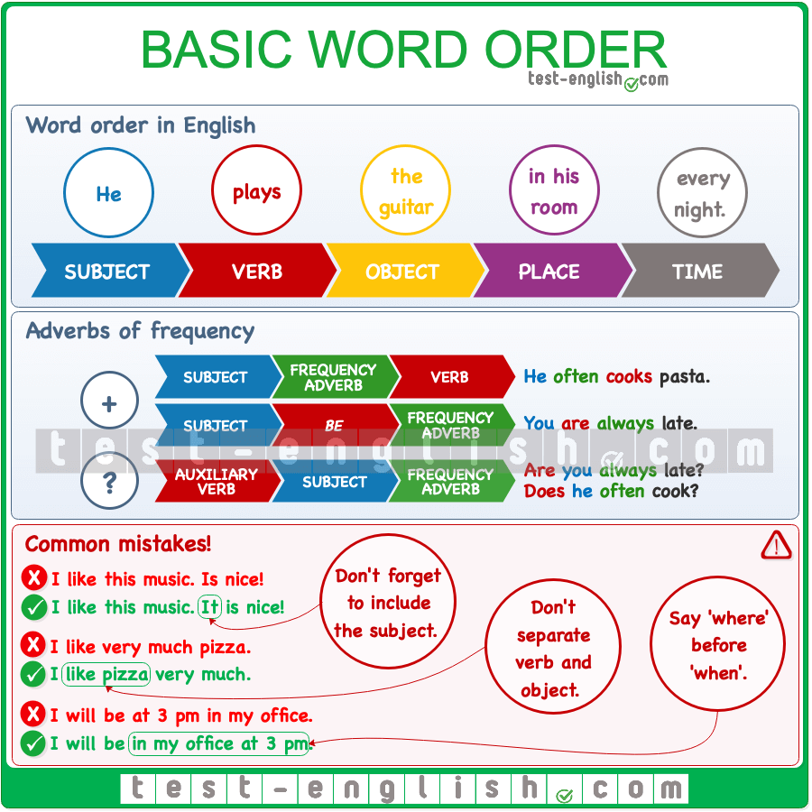

Exercises on word order in English sentences and questions:

<https://www.englisch-hilfen.de/en/download/worksheet_word_order_sentences1_en.pdf>

<https://www.englisch-hilfen.de/en/download/worksheet_word_order_questions_do_en.pdf>

<https://www.englisch-hilfen.de/en/exercises_list/satz.htm>

<https://www.englisch-hilfen.de/en/exercises_list/fragen.htm>

# Class III

## 1. Possessive adjectives and possessive pronouns

**Possessive adjectives (+ noun)**

My

Your

His/Her/Its

Our

Your

Their

**Possessive pronouns**

Mine

Yours

His/Hers/Its

Ours

Yours

Theirs

<https://www.englisch-hilfen.de/en/grammar/pronomen.htm>

Exercises:

<https://www.englisch-hilfen.de/en/exercises_list/pronomen.htm>

## 2. Roles in a web development team

### 2.1 Watch the video “The Roles of a Software Development Team”

<https://www.youtube.com/watch?v=hvDTweQJWRg>

### 2.2 Read the article “Website development team structure every start-up should know about

<https://www.cleveroad.com/blog/web-development-team-structure>

Exercise – after reading each paragraph, write down the main ideas on the whiteboard

See photos of the third class below for discussion

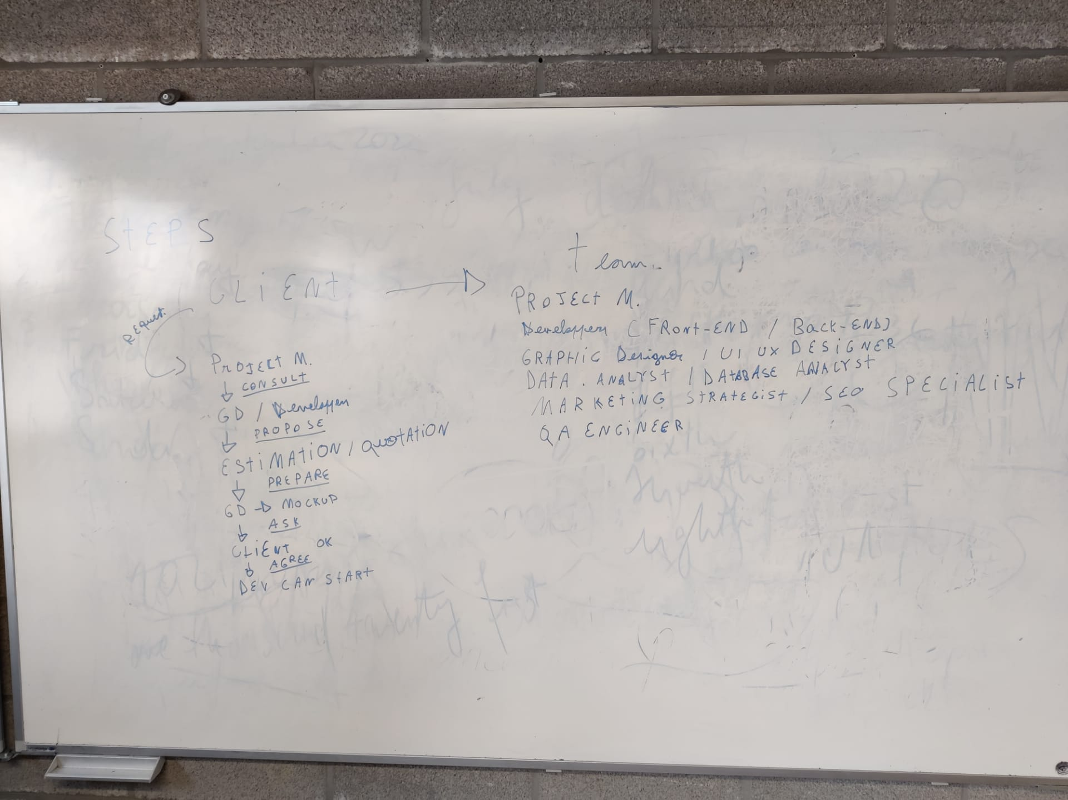

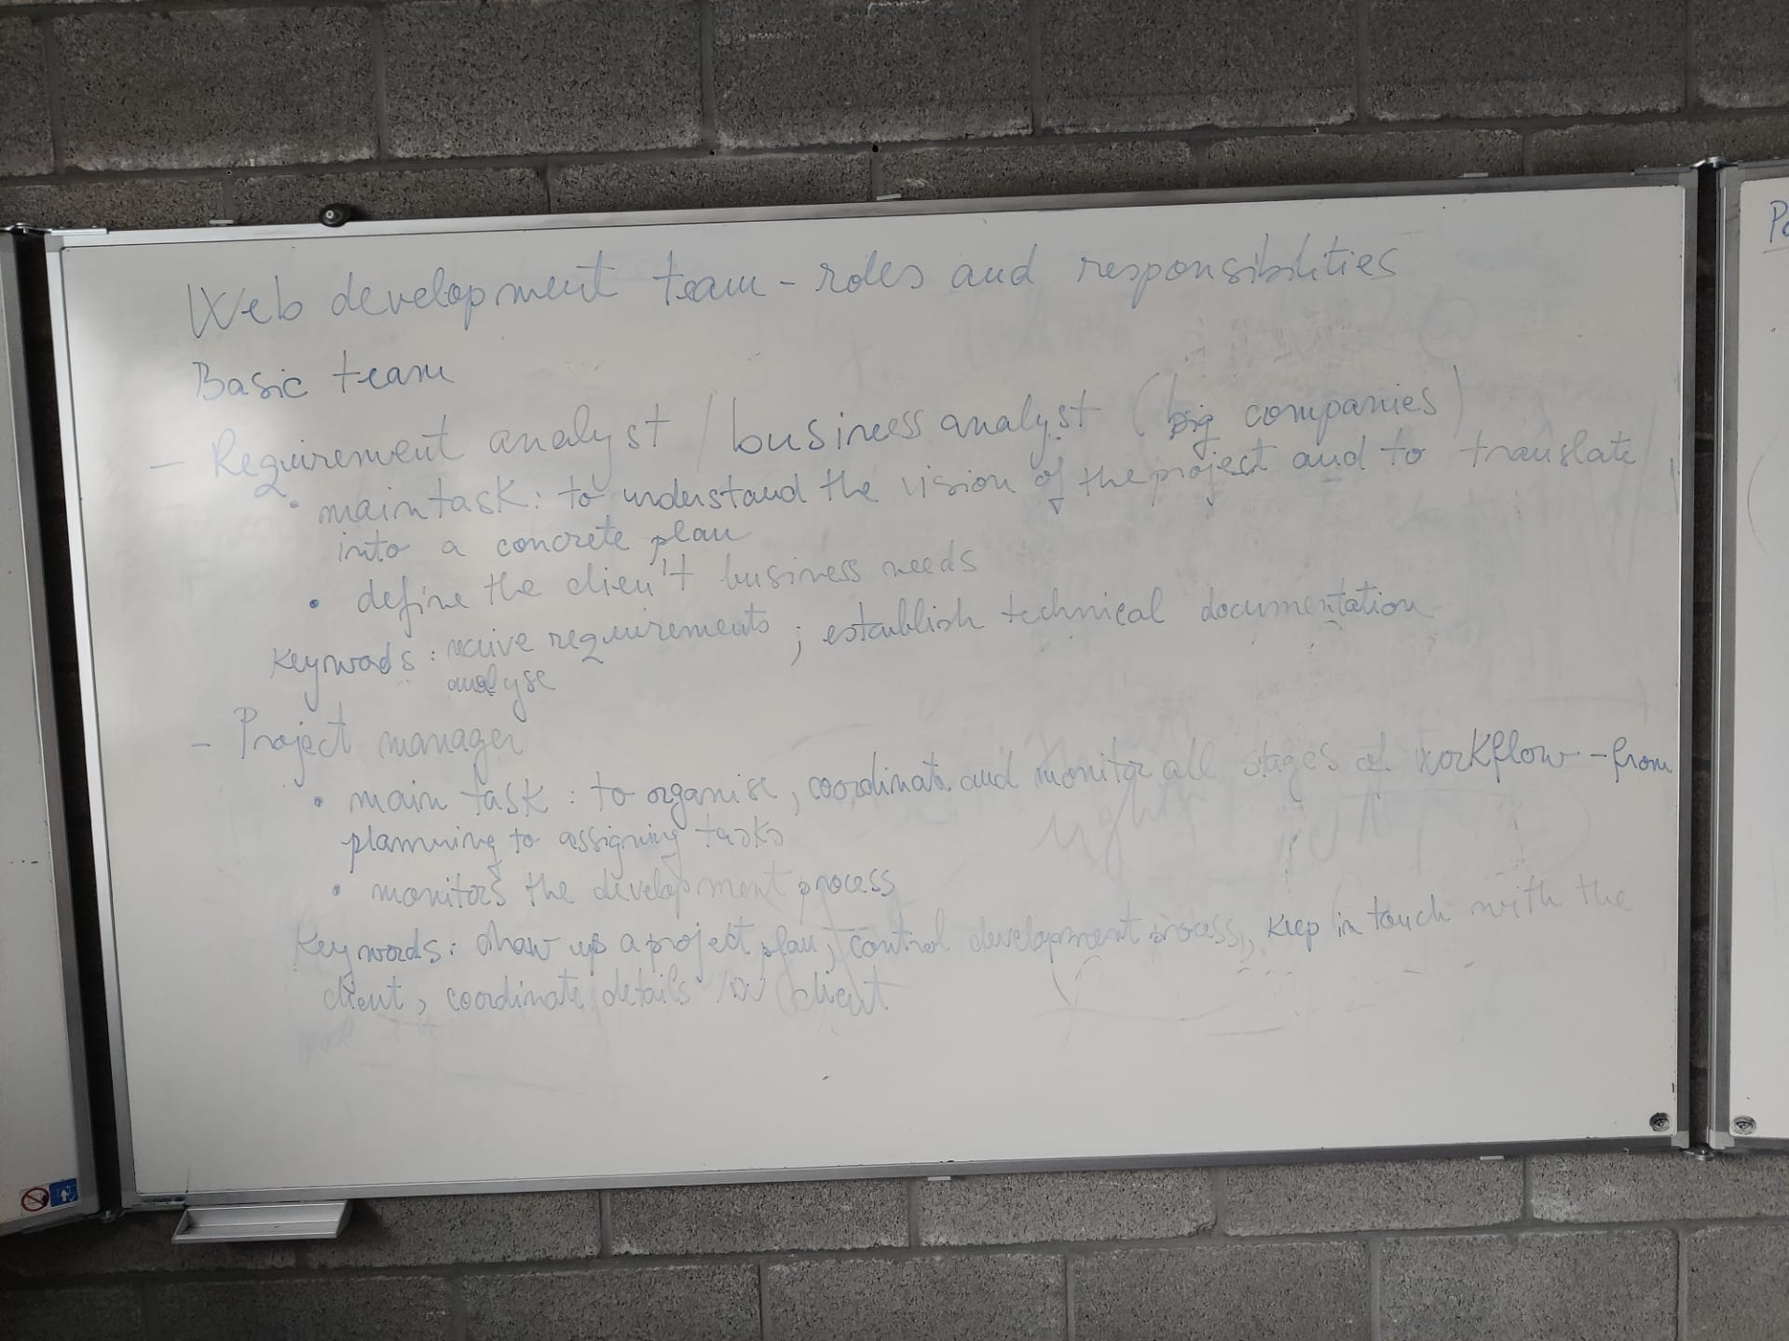

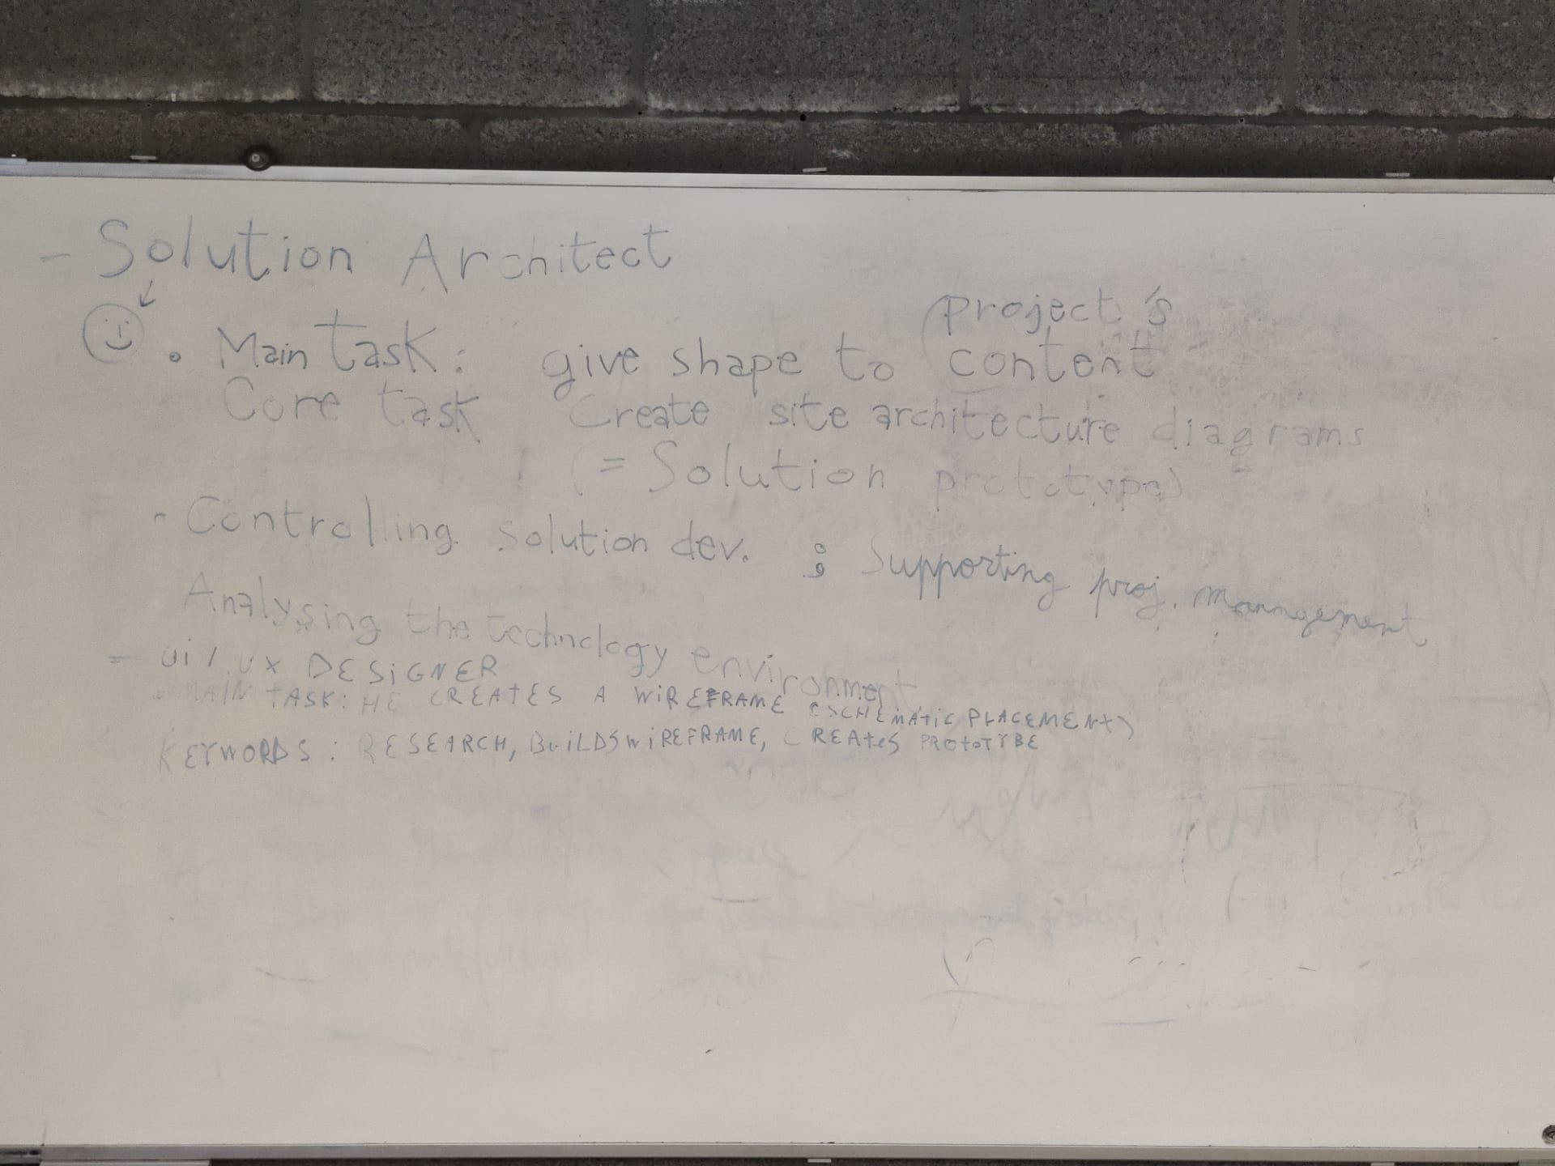

# Class IV

## 1. Watch the video “Frontend Development explained in 2 minutes // Tech in 2”

<https://www.youtube.com/watch?v=qyHyFsT7Hig>

## 2. Write the main ideas of the video on the whiteboard. See below the results of the exercise

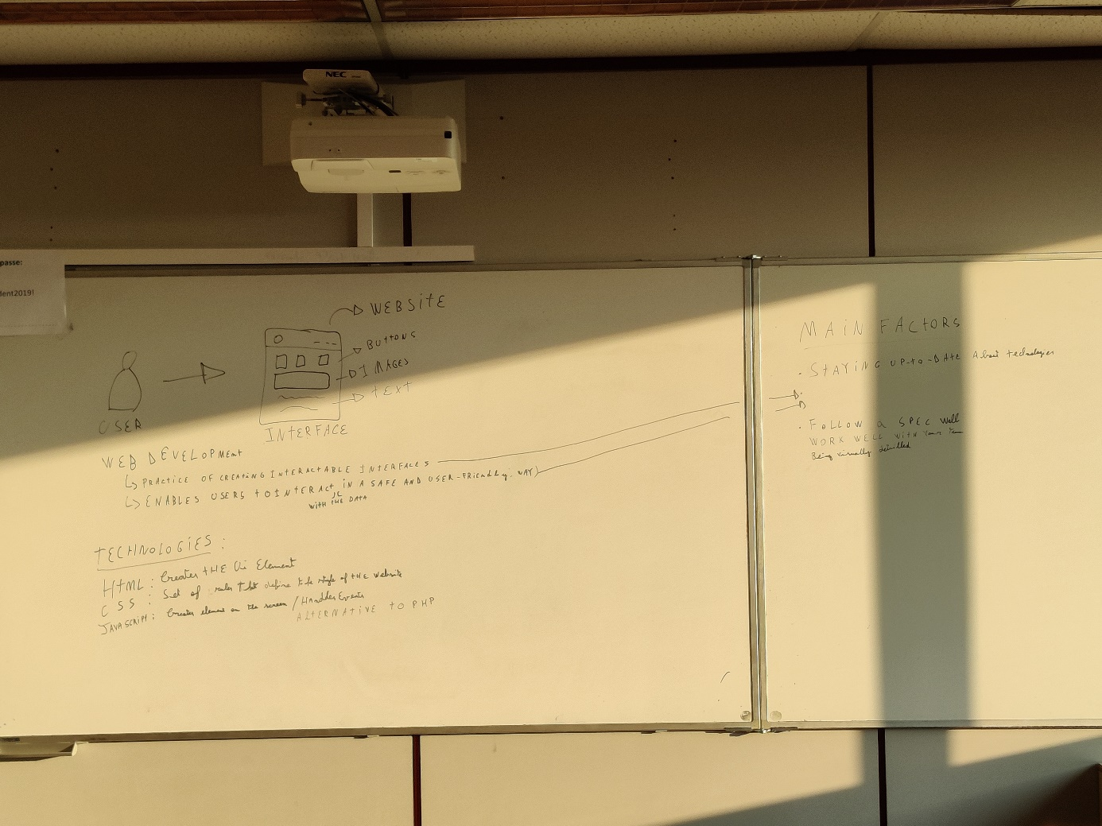

## 3. Write a summary of the video starting from the main information written down on the whiteboard

**Result**:

**Front-end development :**

**The journey**

**Today, Gillian, Guillaume, together with our teacher M Dorina  we watched a video from the youtube channel of Ms Mayuko (https://www.youtube.com/watch?v=qyHyFsT7Hig) describing the job of front-end developer and we are going to explain it to you.**

**First of all, we picked ~~up~~ this video after watching several others, because we thought that the simplification work done by Mayuko could allow anyone to learn more about the subject without prior knowledge.**

**She starts the video by describing in ~~the~~ big lines what covers the front-end aspect of the creation of a website; integration of the website elements such as buttons, images, texts that make the interface interactive to the user.**

**She describes the main goal of a front-end developer as creating interfaces that are safe and user-friendly so you can translate all the information you wanna give to the user.**

**There~~’s~~ are three main technologies that power the development of the front-end :**

* **HTML : with this language you can create UI elements**
* **CSS : ~~that one~~ sets ~~of~~ the rules that define the style of the website (its fonts, spaces, etc)**
* **JavaScript : this one is a “programming” language. It allows to create elements, handle events to create action and interaction with the users and can also serve as an alternative to PHP to exchange data with a server.**

**In conclusion, there are three main factors that lead to the key of a good front-end web developer. The first one is to stay up-to-date because technologies evolve and you need to be able to use them at their best by adapting yourself constantly.**

**Secondly, you need to make simple, interactive and user-friendly interfaces.**

**Finally, you need to be visually focused on ~~detailled~~ details and be able to communicate ~~on it~~ precisely with the other members of  your team on this topic.**

# Class V

## 1. Most common mistakes in English:

<https://www.englishcurrent.com/grammar/common-english-mistakes-quiz/>

## 2. Revision of present tense simple

Exercise:

<https://www.englisch-hilfen.de/en/complex_tests/simple_present1/index.php>

## 3. Revision of possessives:

Exercise:

<https://www.englisch-hilfen.de/en/exercises/pronouns/possessive_pronouns2.htm>

# Class VI

## 1. Read the article “What Does a Front-End Developer Do?” and extract the main ides

<https://www.coursera.org/articles/front-end-developer>

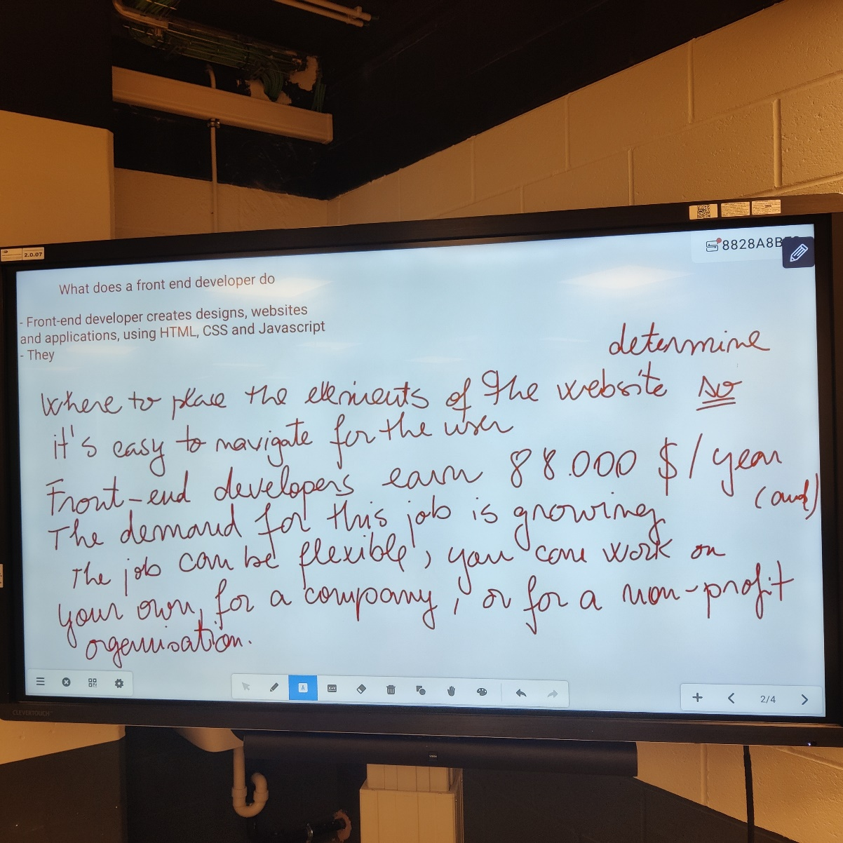

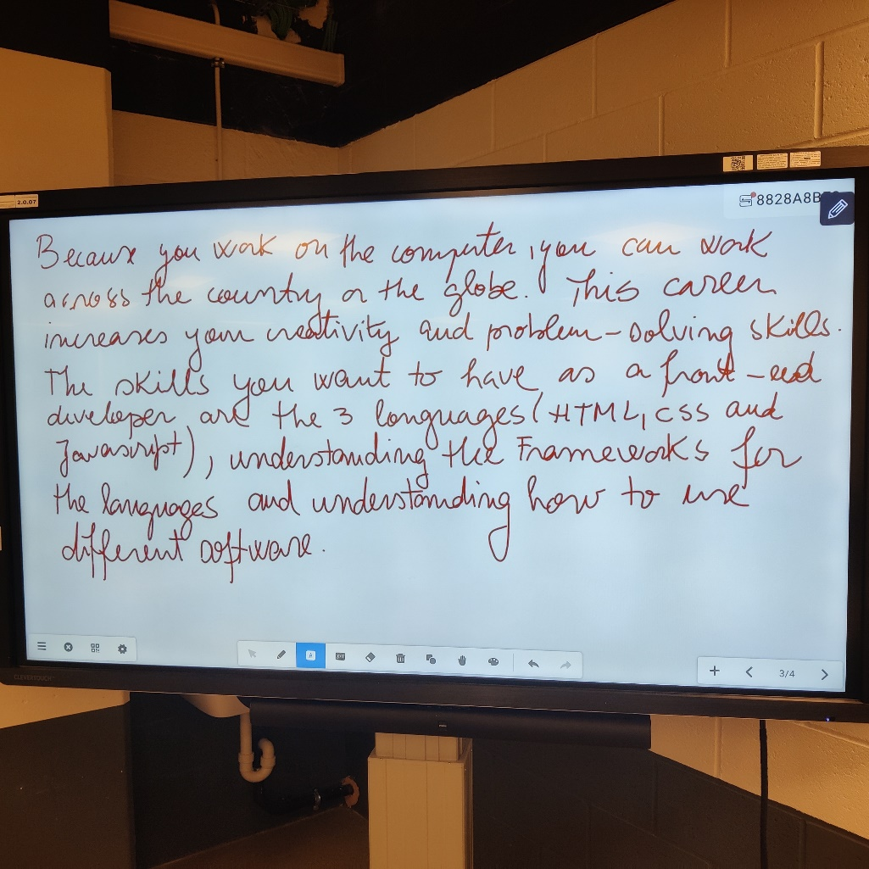

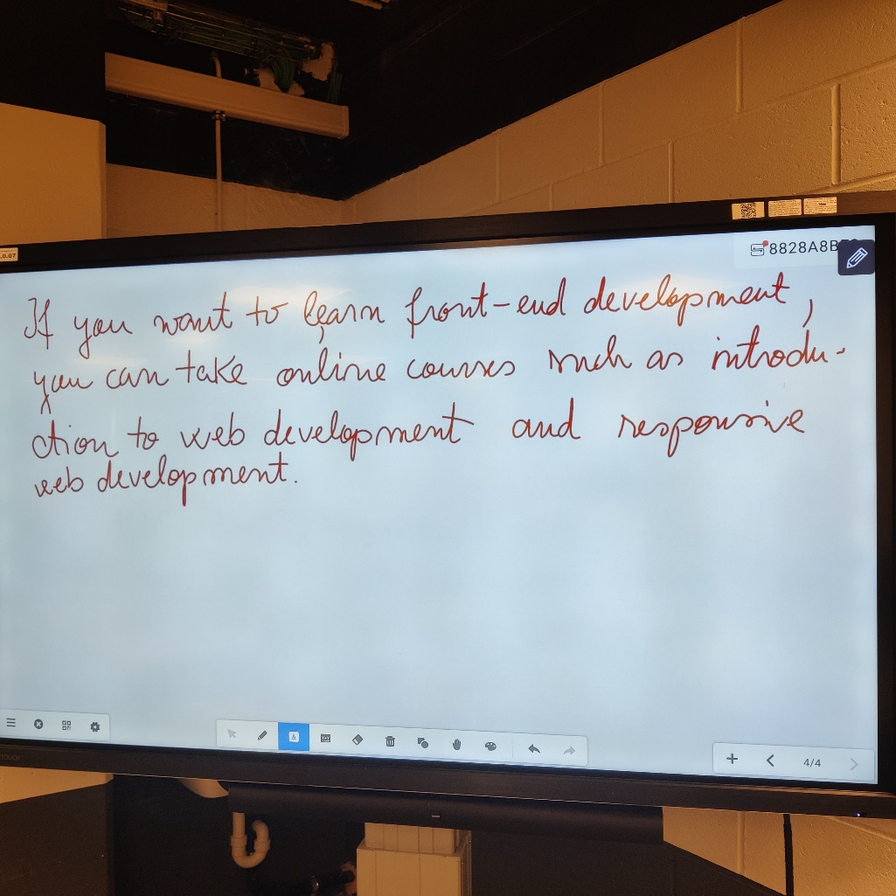

## 2. Write a fluent text starting from the ideas written on the Clevertouch, by using the connective words and phrases below:

<https://www.oxford-royale.com/articles/words-phrases-good-essays/>

You can find the results on Github (see front end article)

## 3. Definite and indefinite articles – a/an + the

See the grammar explanations below:

<https://www.englisch-hilfen.de/en/grammar/artikel.htm>

<https://www.englisch-hilfen.de/en/grammar/artikel2.htm>

Exercise:

<https://www.english-grammar.at/worksheets/articles/art003-definite-indefinite-articles.pdf>

Further exercises:

<https://www.englisch-hilfen.de/en/exercises_list/artikel.htm>